**Final Lab Exam Marks (100) - Time (2 hrs.)**

# Part-1 MCQs (5)

1. How many child widgets can be added to the Container widget?

a. Unlimited children widgets

b. Only one child widget

c. Two children widgets

d. Three children widgets

Answer: b

2. This widget is used to wrap a Column, Row, Container, or other widgets. This widget adds a fillingsize around the child widget. Which of the following term is this definition for?

a. Image

b. SnackBar

c. Padding

d. AlertDialog

Answer: c

3. You may add a lot of properties to your Container widget such as background color, size, padding, margins, borders or the shape of text, and other properties.

a. True

b. False

Answer: True

4. If you created a Flutter app using the Firebase services where the app users had to login to this Appusing Firebase user accounts (email and password), which of the following Firebase products store theseapp users' accounts?

a. Database

b. Authentication

c. Storage

d. Hosting

Answer: b

4. This widget helps you to have a specific width and/or height between widgets. Which of the following term is this definition for?

a. AppBar

b. SizedBox

c. SafeArea

d. onChanged

Answer: b

# Part-2 (50)

**Question-1**

Write the Code for the following GUI

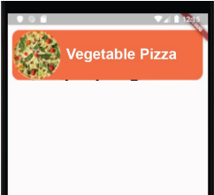

**Question-2**

Write the code for the following GUI



**Question-3**

Write the code for the following GUI

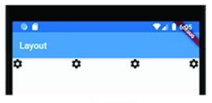

**Question-4**

Write the code for the following GUI

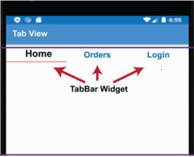

**Question-5**

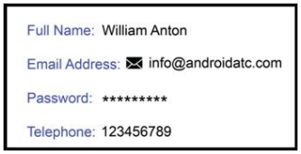Design the card

# Part-3 (45)

**Question-1 (20)**  
In your app, you have two screens. From the first screen, you want to show a second screen. From the second screen, the user must be able to go back to the first screen, and this result must be obtained without implementing any navigation code.

**Question-2 (25)**

You have the main page, which contains a text field for username and a password field. This page inputs the username and password and forwards this data to a new page (let's say SignIn). The SignIn page receives the username and password and displays them in a Text.